SIMATS ENGINEERING

ASSESSMENT TOOL 3

COURSE NAME: Cryptography and Network Security COURSE CODE: CSA51

COURSE OUTCOME COVERED

CO1: Apply classical encryption techniques using symmetric and asymmetric ciphers to encrypt and decrypt data for the ensuring data security. (BL3, BL4)

Assessment Tool Weightage: 10%

QUESTIONS: 5 Total Marks:50

Annexure A

TECHNICAL PRESENTATION

Code of Conduct:

I GNANA PRIYAN G (192521393) (Name / Reg No) certify that this submission is my original work and that I have adhered to the guidelines specified for this assessment.
I understand that any violation of academic integrity rules will result in disciplinary action.

Signature of the student:

Annexure A

TECHNICAL PRESENTATION

- From Caesar to Vigenère: Evolution of Substitution Ciphers”
- “Substitution vs Transposition: Which Provides Better Security?”
- “Security Attacks, Threats, Risks and Their Impact on Security Goals”
- “Steganography vs Cryptography: Hidden Security in the Digital World”
- “Role of Number Theory in Cryptography: From Euclid to Euler”

RUBRICS FOR CALCULATION:

Criteria | Weighta ge | Level 4 –  Exemplary | Level 3 –  Proficient | Level 2 –  Developing | Level 1 –  Beginning
Understandi ng of Concepts | 25 | Demonstrates thorough understanding and effectively integrates multiple concepts/technolo  gies | Good understandi ng with proper integration of most  concepts | Basic understandin g; limited or partial integration | Poor understandin g; unable to integrate concepts
Experiment al Design | 30 | Well-planned, systematic implementation with optimal  solution | Correct implementat ion with minor issues | Basic implementati on with errors or  inefficiencies | Incorrect or incomplete implementati on
Use of Tools | 20 | Effective and advanced use of tools/technologies with proper  configuration | Appropriate use of tools with correct execution | Limited or inconsistent use of tools | Incorrect or minimal use of tools
Analysis of Results | 15 | Insightful analysis with accurate interpretation and validation of results | Good analysis with reasonable interpretatio  n | Basic analysis with limited insights | Poor or incorrect analysis of results
Documentat ion | 10 | Clear, well-structured documentation with diagrams,  code, and results | Organized documentati on with necessary  details | Basic documentatio n with missing  details | Poor or incomplete documentatio n

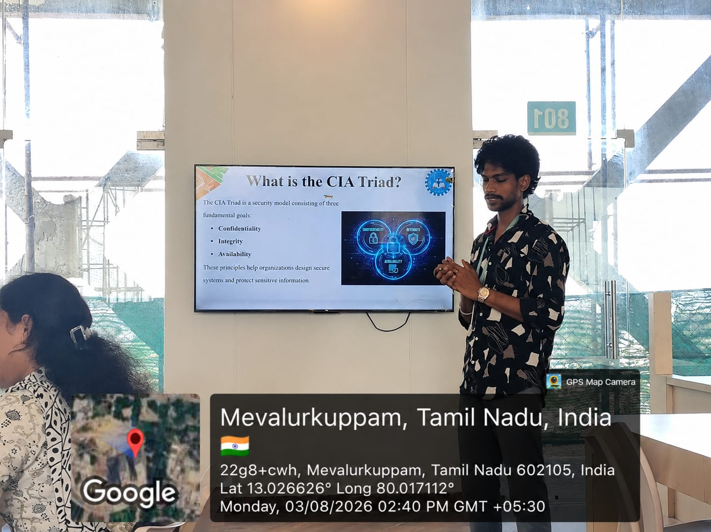

ABOUT MY TOPIC
The CIA Triad is the fundamental security model of information security and consists of three essential principles: Confidentiality, Integrity, and Availability. It serves as the foundation for designing secure systems and protecting valuable information from unauthorized access, modification, or disruption. Confidentiality ensures that sensitive information is accessible only to authorized users through methods such as passwords, multi-factor authentication (MFA), encryption, access control, and biometrics. Integrity ensures that data remains accurate, complete, and unaltered by using techniques such as hashing, digital signatures, checksums, version control, and audit logs to prevent unauthorized changes. Availability ensures that systems, services, and data remain accessible whenever required through regular backups, redundant servers, disaster recovery plans, UPS power backup, and load balancing. Together, these three principles help organizations protect sensitive information, maintain secure communication, prevent cyberattacks, build customer trust, comply with legal and regulatory requirements, and ensure continuous business operations. Without the CIA Triad, organizations face significant risks such as data breaches, financial losses, service disruptions, and damage to their reputation. Therefore, the CIA Triad remains the cornerstone of modern information security and plays a vital role in safeguarding digital assets and ensuring the reliability, confidentiality, and accessibility of information.

